Carnival’s Got Talent Heats supported by



Venue : The Village Hotel, THE GREEN BUSINESS PARK, B90 4GW
Date : Sunday 23rd May from 2p.m.

Under 16 year olds £5
Over 16s £10
Groups £20

Competitors get the equivalent of their entry fee in vouchers for a carvery meal at the Village Hotel. More Prizes to Follow.

Finalists get to perform at carnival with BRMB.
WINNERS get a 3 song studio recording session!

In order to secure your place in the heats, detach the form below and include a cheque made payable to “Solihull Carnival” to :
Carnival’s Got Talent, 7 Clarence Grove, Shirley, B90 3HZ.

Name(s)

Age/ age range

Brief description of act

Contact Address

Contact number
Contact e-mail

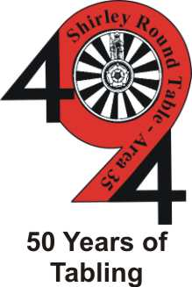
To find out more about either organisation and their forthcoming events please email:
chairman@ shirleyroundtable.co.uk or chairman@ shirleyladiescircle.co.uk

