Name of Organisation
Contact name
Contact address
Contact telephone no’s | Daytime: evening: mobile:
Email address (please!)
Type of stall (description)
Frontage required (in feet)

PLEASE NOTE: (Charity/Community Organisation Stalls)

- Lotteries offering alcoholic prizes are not permitted.
- Due to the requirements of the health act, food stalls may only be organised by or with the written permission of Round Table.
- Frontages will be strictly marked out in accordance with your application and so you should ensure that your application is sufficient.
- Round Table does not make a specific charge for Charity Stalls. However, as Carnival is designed to raise money for our Charity Account for onward distribution to a range of local groups and charities, we request a voluntary contribution.
- Stallholders will be issued with one vehicle pass and two ground passes just prior to the Carnival date.
- Stallholders will not receive a trestle table or chairs. Trestle tables and chairs are only available if booked at the time this form is returned and are chargeable as detailed below.
- Acceptance of your application will be at the discretion of the Carnival Committee
- Email communication is welcomed

We require ……… 6ft trestle tables @ £6 each = £ We require ……… chairs @ £3 each = £


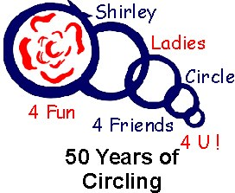
Proposed Charge £ ………………….. (subject to agreement) TOTAL AMOUNT enclosed £ ………………… (Cheques payable to Solihull Carnival)

